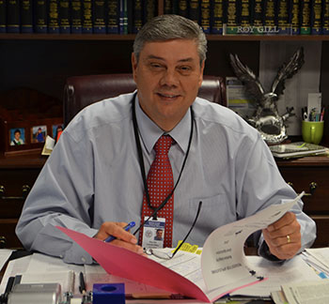

Harrison County School District is committed to excellence by focusing on each individual student and providing exemplary instruction. Our schools serve unique communities that encompass both rural and urban neighborhoods.We have created a culture of teaching and learning that starts with students’ earliest entrance into our programs and follows them throughout their school years. At the earliest levels of our students’ education, we partner with private educational agencies in the area of pre-K curricula and student preparation. We recognize that a well-rounded education inspires students and encourages their individual talents. As students progress through our system, we fully support their pursuits of extra-curricular activities such as band, athletics, fine arts, computer science, and robotics. Our rigorous instruction includes accelerated classes in all schools. We offer a variety of dual-credit and advanced-placement classes that allow students to earn college credits while attending high school. Our flexible course offerings accommodate both college-bound and career-bound students. Students may earn industry certification at the high school level that will allow them to pursue a career immediately after graduation. Our district offers graduation tracks that are traditional, early exit, and fast track. We support our faculty and district employees by providing continual high-quality professional development and learning opportunities. As superintendent, I am proud to be a part of a team that is dedicated to caring for and educating our communities and the world’s next generation of workers, leaders, and stewards of the future.

